Manual For GetFitGetLit

1. First download the GetLitGetFit2.zip folder.
2. Unzip folder and launch executable.

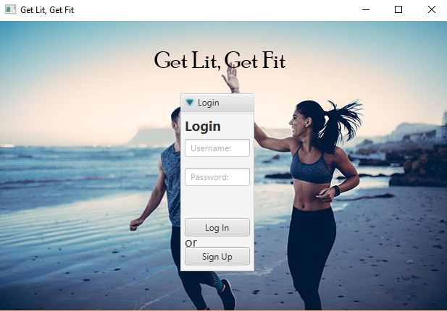

1. To Sign up click the Sign up button.

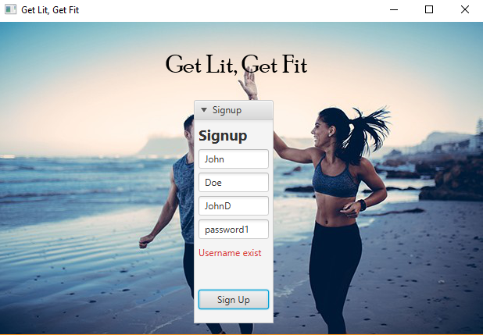

1. Enter your name, last name, username and password information.
2. make sure to use a username that is not already taken.

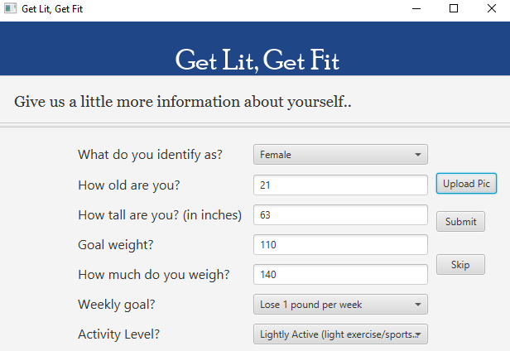

1. Enter your more personal information on the sign up window and upload a photo of yourself.

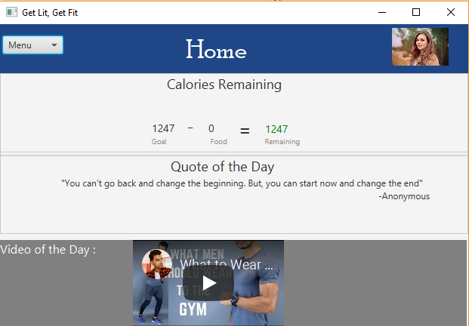

1. You should be directed to our home screen which tracks your daily calorie intake limit

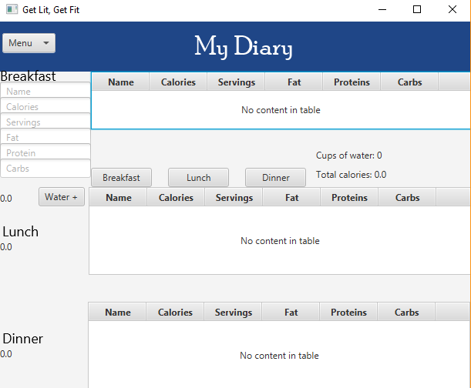

1. On the diary page you may add food or water intake inside the tables for breakfast lunch and dinner.

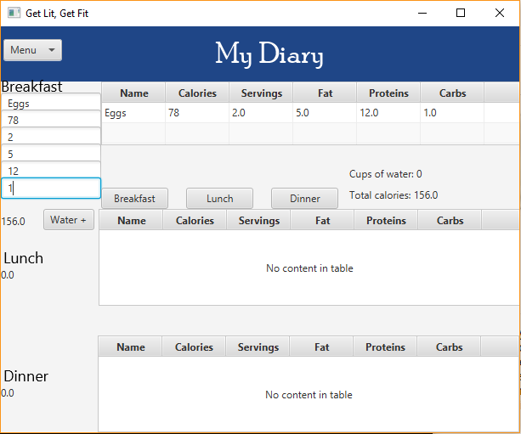

1. Now if you go back to the home page your calorie intake should be deducted from your calorie limit for the day.

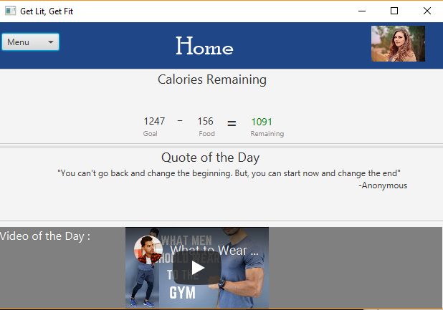

1. Press the menu bar and logout and you will be brought back to the login screen

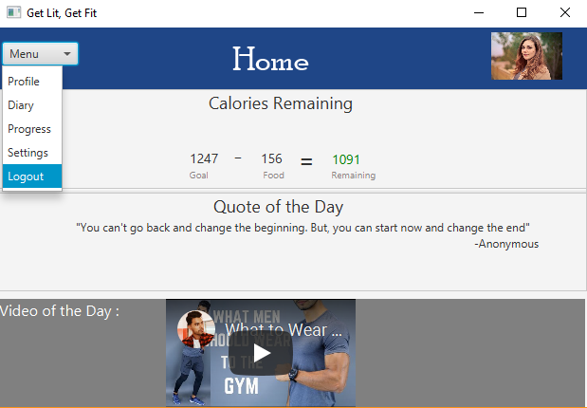

1. Now if you use the username and password from the account you just created, you may log back in and track your calories and live healthy!

